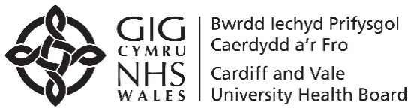
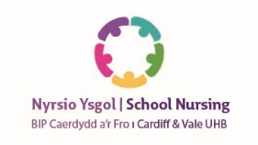

Dear Parent/Guardian Date Jan 2024

The School Health Service/Child Measurement Programme for Wales
Welsh Government has set up the Child Measurement Programme for Wales. This surveillance programme is run by Public Health Wales and is designed to help us better understand patterns of children’s growth across the whole of the country. The height and weight of each child in a reception class in Wales will be measured. Measurements will be taken in a school setting by a trained member of the healthcare team. Children will be asked to wear normal light clothing and take off their shoes.
This information helps the NHS improve the health services provided for children, including those that help them maintain a healthy weight. All information used by the programme will be treated confidentially and no information identifying your child will ever be published.
If you are happy for your child to participate in this programme you do not need to do anything more. However, if you do not wish your child to be included, please let the school nursing service know by ringing the telephone number below, stating your child’s name, DOB and school.
More information about the child measurement programme is available on a separate leaflet as well as on the NHS Public Health Wales website:
www.publichealthwales.org/childmeasurement
Yours sincerely
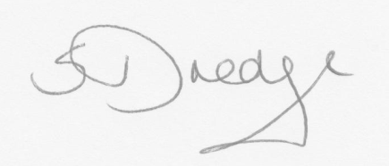
Sandra Dredge. Senior Nurse, for Community Child Health Nursing.
Your School Nursing Team is:
East Team 02921833114

