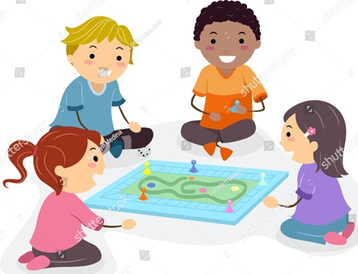
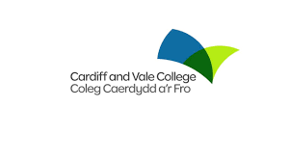

Families Learning Together
Developing a child’s number and shape skills Course

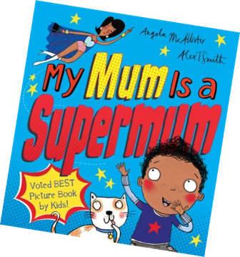

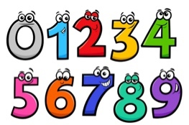

for parents and children in
Reception and Year 1

Work with your child and develop new skills helping to support them with their maths in this fun, friendly 10-week accredited course.
When: Thursday 9am (Starting 5th May)
Where: Coed Glas Primary School

Come along and find out more !

