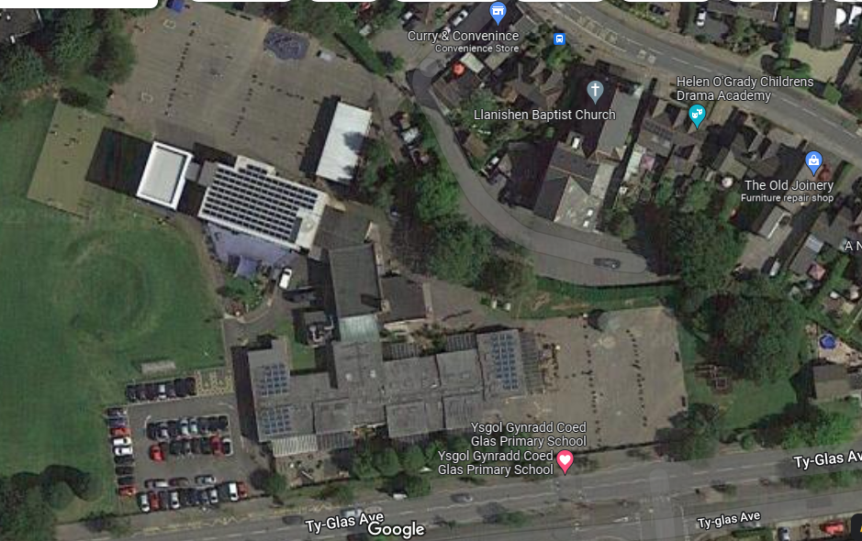
Rear door
Foundation Yard
KS2 Yard
Staff entrance
Portacabins
Nursery

