

A PARENTS’ SUPPLEMENTARY GUIDE TO TRANSITION



Transition from primary school to secondary school is a very anxious time.

How will this be managed?

Before they arrive:
At present, Llanishen High School takes pupils from many primary schools. Our largest intake being from those within our Cluster: Bryn Celyn, Coed Glas, Glyncoed, Llanishen Fach, Llysfaen, Pontprennau, Ton-yr-Ywen and Thornhill. We also welcome a number of pupils from other primary schools including Springwood, Llanerderyn, Birchgrove, Rhiwbina and around 20 other primary schools. A number of pupils also come into our Specialist Hearing Impaired Unit and our Specialist Autism Base.
We recognise that the transition from a familiar and much-loved primary school is an anxious time for pupils and parents alike and to help this we have a member of the Senior Leadership Team dedicated to overseeing and co-ordinating the transition. This is Mr Andy Mee, Transition Coordinator, who co-ordinates the following:

- Our Assistant Head, Andy Mee, The Year Team Leader, Mrs Vicky Thorne, and the Pupil Achievement Leader, Mrs Mariella Francis, will visit the primary schools alongside our Year 7 Buddies Team to introduce themselves to the year 6s. The buddies will give year 6s a chance to ask some frequently asked questions and provide reassure to the year 6 that all will be well.

- The opportunity will be given for those joining us from outside the Cluster to visit our school, meet the year team and ask any questions that they may have.

- Mrs Thorne, Mrs Francis and members of the wellbeing team will visit the Primary Schools to meet with our Year 6 colleagues about each pupil. They pass on key information relating to each pupil.

- Our additional learning needs team, led by our ALNCo (Additional Learning Needs Co-ordinator), Mrs Ellen Pawar also liaises with each of the primary school ALNCos to gain more in-depth information on pupils’ additional learning needs.

- Colleagues from our Hearing-Impaired Base and Autism Base, led by Mrs Estelle Williams & Mr Charlie Batten, will liaise with individual pupils in their primary schools to discuss their needs and ensure they are grouped appropriately.

- We arrange two formal visits to Llanishen High for our year 6 pupils throughout the summer term and one parents’ evening. These include:

  - Transition Afternoon – This gives pupils the opportunity to be placed in their form classes and meet their new form tutor and peers within their form class.

  - Transition Parents’ Evening – On the same day as the transition afternoon we hold a parents’ evening where parents and guardians are given the opportunity to meet staff, see the school, hear important information about our school and ask any questions that they may have.

  - Induction Day – This is a full day at Llanishen High School, where pupils come up and take part in activities alongside their form group. We give pupils an opportunity to get to know the site, get their thumb prints ready for lunch on the first day and experience what a day-in-the-life of Llanishen is like!

- Our Buddies team and staff are there to support pupils every step of the way during their visits to LHS.

When they arrive!
- In September, pupils will spend time with their form tutor, receiving their student planners and timetables for the year and then we begin!

- Year 7 have exclusive use of the West Wing dining hall during their lunch break to enhance their lunchtime experience and allow them to acclimatise to the big and bustling setting.

- We arrange a parents’ settling-in evening early on in the Autumn Term. This is an opportunity for parents to come into school and speak with their child’s form tutor. For the vast majority, this is simply an opportunity to hear that their son or daughter has settled well. In fact, many pupils feel like they have been here for years. But it is also an opportunity for parents or the form tutor to voice any concerns or worries that they may have so that they can be addressed.

- Parents receive a termly progress report on their child in all subjects and are invited to a full parents’ evening to meet all the teachers in the spring term.
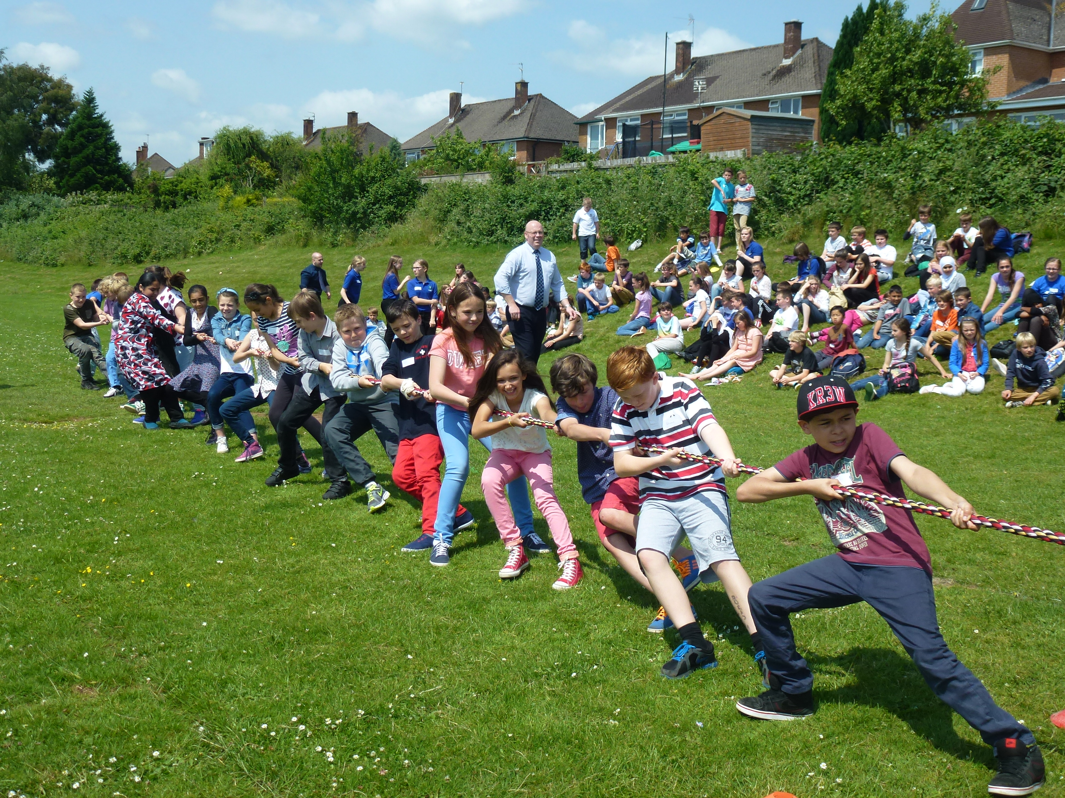
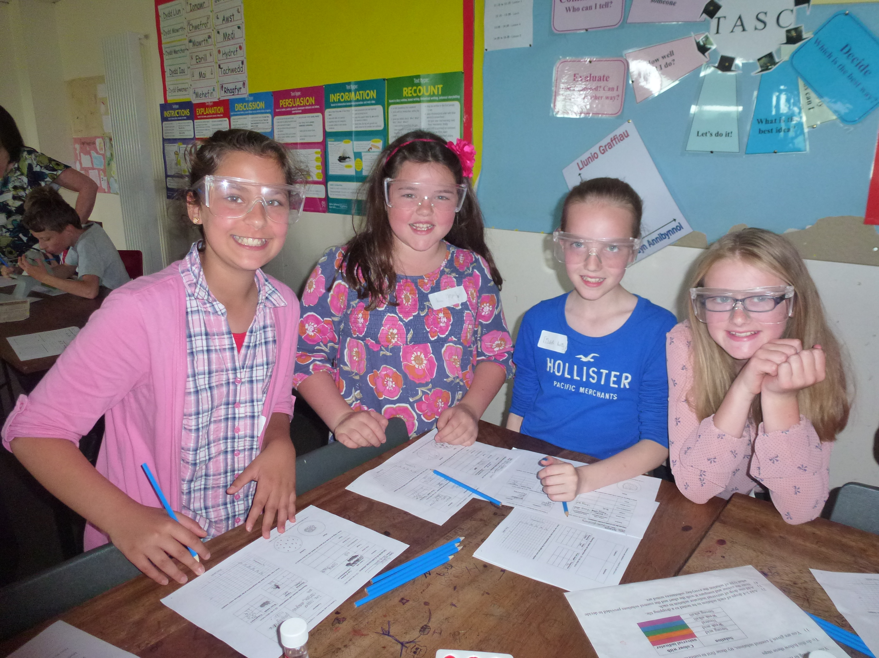

Frequently asked questions:

What issues is the school strict about?

We set high standards because we want everyone to be successful. In order to raise the levels of pupils’ achievements certain things need to be in place:

- School uniform. It is important that the pupils adhere to our uniform policy at all times. A smart uniform gives a clear message to the wearer and to the local community about how serious we are about learning. It ensures that the pupils arrive at school with a sense of purpose and identity. The uniform is simple, practical and cost effective comprising of a school blazer, shirt and tie, jumper or cardigan, black trousers or black skirt and polishable black shoes. All of these items can be purchased from our supplier YC sports – a outline of the required uniform will sent to all parents, is set out in the school prospectus and available on the LHS website.

- Behaviour in classrooms, corridors and around the school. We expect courtesy, respect and consideration from all members of the school community. Our school rules are simple and are consistently explained to the pupils. We have a comprehensive Positive Behaviour Policy that rewards good behaviour and applies a staged system of sanctions to combat poor behaviour where it occurs. This allows us to take action in a clear, calm and consistent manner. As with all aspects of school life, we believe that keeping parents informed is crucial and make no apologies for telephoning parents to discuss the behaviour of their children.

- Attendance. Students can only learn if they are in school. As well as a legal requirement, regular attendance and punctuality are good habits essential to the continuity of education and to any future employer. We set a minimum 95% attendance target figure for all pupils. Llanishen High School regularly returns attendance figures in line with Welsh Government targets but we are always mindful of the need to maintain these standards. Holidays during term time are not permitted because of the adverse impact on pupils’ learning.

- Mobile phones. Pupils are not allowed to use a mobile phone at any time during the school day. Any pupil who brings a mobile phone into school, does so at their own risk.

What will my child be studying at Llanishen High School?

The curriculum is the complete educational programme offered by the school. It is designed to develop the intellectual, spiritual, physical, emotional and social attributes possessed by all children.

Key Stage 3 Curriculum

We work very closely with our associate primary schools to ensure as seamless a transition as we can for the pupils in terms of the continuity of their learning. The knowledge and skills that they develop in Key Stages 1 and 2 form the solid base for progression at Key stage 3. Your child will follow a curriculum in year 7 that has been designed with our primary school colleagues.
Your child will have lessons in English, Mathematics, Science and Technology, Humanities, Expressive Arts, Languages and Health and Well-Being. There will be collaboration between subjects to ensure the principles of the Curriculum foir Wales will be integrated into their learning experiences.

When the pupils move into year 8 they have the same form tutor, and will continue to follow the same subjects, as they did in year 7. Some subjects are blocked together so that courses, learning and teaching can be organised for the maximum benefit of all pupils. This allows for setting according to each pupil’s ability and aptitude.

Key Stage 4 Curriculum

In years 10 and 11, the curriculum consists of two parts, the ‘core’ and the ‘options.’ In the Core, all pupils take English, Maths, Science, Religious Education, Welsh, ICT and Physical Education.

The requirements set by the Welsh Government for 14-19 education mean that Llanishen High School must offer its pupils a broad range of high-quality learning opportunities. The school does this in conjunction with its partner high schools in the Cardiff 14-19 network. The options offer includes Art, Business Studies, Computer Science, Drama, Engineering, Geography, History, Photography, Hospitality, Catering, Design Technology, French, Media Studies, IT, Sport, Health and Social Care and Music.

We also offer vocational placements with local colleges and training providers for one day a week covering areas such as construction, catering and military training. On site, the school offers Hair and Beauty courses in our own Hair and Beauty Salon.

The Sixth Form Curriculum

In our thriving 6th form, Year 12 students normally take 4 subjects to AS level. In Year 13, they normally take 3 of those subjects to A2 level. Oxford and Cambridge entrance preparation is part of our provision. This year, we have had students accepted to study in both Oxford and Cambridge.

In year 12 and 13 students also study the Welsh Baccalaureate at advanced level to gain further Key Skill qualifications and accredited UCAS points.

Will our child receive sufficient and meaningful homework?

The school aims to set rigorous and meaningful homework. The homework timetable is published and is available to parents on the school’s website and in the pupils’ planners. The purpose of homework is to support and extend the learning that takes place in the classroom and to train pupils to become effective and independent learners. Pupils record their homework in their ‘student planners’ along with the deadline so that parents can monitor what is being set and its completion. Parents do sometimes raise concerns about the adequacy and appropriateness of homework. Such concerns are addressed promptly.

How do you care for the whole pupil at Llanishen High School?

Pupil wellbeing is an essential priority for the school. We firmly believe that children will only flourish in our school and develop into independent learners if they are supported by a structure of care and discipline. We tailor our curriculum to provide challenge and stimulation for each pupil.

We operate an extensive mentoring programme called the ‘Achievement Scheme’ as well as workshops for pupils with social anxiety issues or who need a boost in their self-esteem. The Achievement Scheme and workshops are led by a member of our teaching staff who is a trained counsellor and operates from a designated nurture room.

The school has designated Child Protection Officers as well as a trained pastoral team that follow the school’s Child Protection Policy procedures.

We also have a very active student body in terms of measures to combat bullying. Our Buddies Team has been active for 12 years and has won various awards from Childline and the South Wales Police. The team has many volunteers from Year 9 who are trained to be peer mentors or listeners to fellow pupils. They focus on the transition from Year 6 into 7 and take assemblies on anti- bullying to highlight the school’s anti-bullying policy.

How will I know that my child is making progress in school?

Every pupil is set challenging targets for the end of KS3 and KS4. The students keep track of their progress via interviews with their Form Tutor or Year Team Leader or with a member of the Senior Leadership Team.

Parents receive a termly progress report on their child in addition to the full annual report that details your child’s progress in each subject. Parents can also access their child’s performance on-line via Classcharts.

There is an annual Parents’ Evening to discuss progress with each teacher individually and additional parents’ information evenings on literacy and numeracy. Support staff and the Year Team Leader are always available to discuss any issues or concerns that you may have in relation to your child’s progress.

How do you involve the pupils in the wider life of the school beyond the classroom?

We value our pupils’ views and suggestions and try to involve them fully in all aspects of the life of the school. We have a very active Student Council play a vital role in helping to improve the school environment and appoint new staff. The Head Boy and Head Girl attend Governing Body meetings to contribute the views of the pupils to the work of the Governing Body. The Senior Leadership Team interviews pupils from all year groups about their learning and school experience and we use this information to inform our planning. Each year a group of volunteers are trained as Buddies and help us to run the school by acting as role models and supporting younger pupils. We also have a very active Eco-Committee whose work has resulted in the school receiving the Eco Schools Platinum Award. Llanishen also runs numerous clubs (debating, OAP befriending scheme, gardening club, sports clubs, chess club, homework club, IT club, music & drama activities etc etc) that we encourage all pupils to engage with – indeed if pupils identify a need we would look to develop a new club! We also have very active Charity Committees at Key Stages 3, 4 and 5 that raise thousands of pounds every year for local and national charities.

My child finds some subjects difficult. How will you ensure that he or she receives support?

Children with additional educational needs are integrated into mainstream classes. As pupils progress through the school, we organise them into groups to ensure effective learning and teaching. A team of Learning Support Assistants provide in class and small group withdrawal support for pupils with additional learning needs and there is a programme of withdrawal groups to provide literacy and numeracy support and help with social skills. Pupils on the ALN register are regularly monitored, and we have started to introduce IDPs (Individual Development Plans) for those pupils who need them, in line with the new ALN Bill. We have various small group sessions available at registration times to help pupils with different subjects, and run mentoring programmes with staff and peer mentoring.

My child is bright. How will he or she be stretched to achieve their full potential?

We are extremely proud of our excellent exam results. Our setting policy and differentiation of materials ensure that pupils are challenged to attain their potential.
We identify pupils who are more able and talented (MAT). We involve parents and subject teachers in strategies to challenge them and provide additional ‘enrichment’ days to stimulate and motivate them further. Mr Mee leads on all aspects of MAT and enrichment.
We encourage our pupils to take advantage of extra-curricular opportunities to develop their skills, for example, by representing their year group in the debating club or on the School Council or by writing for their year group newspaper.

My child doesn’t push to achieve well in school.
How will you motivate them?

We recognise that motivation does not occur naturally in all of our pupils and take steps to address this. The school actively mentors those pupils who are struggling to engage in learning. We also operate peer mentoring and staff mentoring as well as referring pupils to other agencies where appropriate.

We are part of a Welsh Government initiative to encourage pupils to talk about issues that may be troubling them and we have a counsellor in school that pupils can refer themselves to. Year Team Leaders identify students who may be at risk of underachieving due to low self-esteem and we work with local youth workers and our own trained staff to run a programmes to combat this. All pupils are rewarded by staff with merits and commendations in line with our Positive Behaviour Policy and pupils are interviewed by their form tutor or member of the Senior Leadership Team to set challenging and meaningful achievement targets.

My child loves reading. How will this be nurtured in school?

In addition to the various literacy initiatives and reading strategies that are implemented during lesson times, we have regular book reviews and run a literacy club. In year 7 pupils are taught a module on ‘information literacy’ that encourages them to be more independent in finding information. Many pupils attend extra-curricular clubs such as Book club and Creative Writing Club. Authors are also invited into school to promote literacy and reading to pupils and the English department are extremely proactive in providing a whole host of literacy based experiences for the pupils.

What is the school’s approach to the teaching of Welsh?

We are proud of our Welsh heritage and believe that a knowledge and respect for the Welsh culture and language adds a unique dimension to a pupil’s education. We use Welsh in our Assemblies and lessons and in March we hold a very enjoyable St David’s Day Eisteddfod for years 7 and 8 as part of a ‘Welsh Week’. We also host an Eisteddfod evening, where pupils from our cluster primaries, together with our own Eisteddfod winners, come together to entertain and impress an audience of parents and staff. We provide opportunities for pupils to attend courses to Llangrannog. Our signage throughout the school is bilingual. All pupils study Welsh up to the age of 16 taking a full course at GCSE.

My child loves sport. What extra-curricular opportunities does the school offer?

Many departments offer a comprehensive range of extra-curricular activities at lunchtime and after school. These include choir, school plays, art classes, geography club, debating, chess, netball, rugby, basketball, athletics, tennis and dance. Pupils play regular inter-school matches and compete very successfully in local leagues and county tournaments. We have an inclusive badminton club after school each week, run by the Learning Support Department. Any pupil is welcome and indeed encouraged to join in one or all of these activities.

What other opportunities are there for the pupils to develop a well rounded education?

Academic achievement is a major focus at Llanishen High School. Results day in August 2019 was indeed a date to celebrate as we achieved some of our best ever GCSE and A Level results.

We also want our pupils to leave with a passion for learning and for life. Our vast extra-curricular programme complements the taught curriculum. The information below is not exhaustive but gives a flavour of our intention to offer something for everyone.

The PE department offer regular outward bound trips to Storey Arms. Pupils are offered educational visits that can be local, national or international. These include trips to Llangrannog (Welsh), France (MFL), Big Pit, Rhondda Heritage Park, Cosmeston Medieval Village (History), geography department field trips, Italy, Spain (PE), Theatres (Music/Drama/English) and Galleries (Art).

Our young musicians are encouraged to join musical groups such as string group, choir and school orchestra. Peripatetic music lessons are also organised through the school. Our annual school shows must be seen to be believed! Many pupils participate in Cardiff and the Vale music ensembles.

I want my child to go on to university or higher education. Where do the students currently progress to?

The strength of our academic results means that a large proportion of pupils go on to universities across the UK and beyond. Others join a range of local training providers and further education colleges and some go into employment.

How can parents be involved in the life of the school?

Our parents are a vital part of the school community. We keep you informed of happenings in the school via our school newsletter and school calendar.

We also offer a free ‘parentmail’ service. If you provide us with an email address we will send you all communications via email. These include letters and Blogs from the Head teacher as well as any other information that is useful for you to know throughout the year. You can also access our school website which contains news of activities and achievements as well as key documents, school policies and exam dates.

You can access your child’s school record from home at any time via our electronic systems. You will be issued with a password to access your child’s current academic, attendance and behaviour (including positive behaviour) record at any time.

We will inform you in advance of any forthcoming events including parents’ evenings and transition evenings.

The PTA provides a focus for parents to support the school and is always looking to recruit new members. The PTA is very active in the life of the school and a real asset in raising money to provide further opportunities for pupils. We run an annual ‘curry and quiz’ night open to parents and the local community. We meet every month and are a friendly and welcoming group.

Finally, the Governing Body has six parent governors who are elected by parents and serve for a four year term. Parents are advised as vacancies arise.

If I need to get in contact with the school, what do I do?

Your child will be coming into year 7 who are led by their Year Team Leader, Mrs Thorne. She is supported by the Pupil Support Team who as they don’t teach are always available to take your phone call and should be your first port of call.

Your child will also be supported by their form tutor. Pupils spend 25 minutes of each day with their tutor either in registration or assembly. This is the tutor’s daily point of contact with their form group. During this time they will check the pupil planners. You can keep in touch with the form tutor via a note in the pupil planner if this is convenient for you.

We recommend that you sign up to our free parentmail service. This will allow you to receive letters and school notices by email. We also recommend that you familiarise yourself with the school website where information is regularly posted for parents and pupils. And finally, you will receive information to allow you to log onto our school information system (SIMS) so that you can follow your child on a daily basis.

We would encourage any parent/guardian who has a question or concern to contact the school so we can discuss and resolve the issue.

Other practicalities

The school day commences at 8:30am for lesson 1 and finishes at 2:45pm. Please note that it is not possible to drive onto the school site during these times as the gates are locked to ensure pupil safety.

In Year 7, we have 3.5 lessons in the morning, lunch at 12:45pm, and then 1.5 lessons in the afternoon.

We encourage pupils to bring healthy snacks and a bottle of water that they can fill up at water stations around the school. Pupils can either bring a packed lunch or buy a school lunch. Packed lunches can be eaten either in the main dining hall or on the red gra outside area (weather permitting!). Hot food that is purchased must be eaten in the main dining hall.

Year 7 pupils ARE NOT permitted to leave the school site at lunchtime to go to the village. This is to provide us all with peace of mind.

